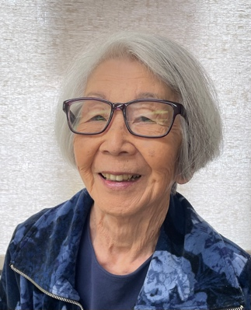

SHIRLEY KURAMOTO

My birthday wish at 89
Is to send out invitations online.
I hope everyone can come
to see the Art I have done.
And then we’ll all drink Mondavi Wine.

The irrepressible Shirley Kuramoto wrote this limerick at the age of 89, as part of her exploration of Poetry in Art, an experimental class she found at The Villages in San Jose. Shirley joined the class to find that people her age would enjoy coming together to read a poem by their poet of choice, discuss it and then create an artwork inspired by the poem. At first participants selected their favorite poem from published work. Then, having learned haiku, people began writing their own haiku and other poems.

It is not amazing that Shirley relishes this particular poetry and art combination, because she has been adventurous all of her life.

Elementary school life in Menlo Park found Shirley more often than not, marching to a different drum. In first grade, her teacher ordered her to stand in the corner when during Art period, she found Shirley coloring a horse, not in customary horse colors, but -- in green! At a teacher-parent conference, her teacher said to her parents, “Toshi will grow up to be a good clown!” What a horrible condemnation then; but the light of her life now because she recognizes there was an element of truth to that statement. Shirley declares her aim in life is to make people laugh and have fun! She is happy with her many adventures and wants to bring joy to others also.

Born in San Jose to first (Issei) generation and second generation (Nisei) born in America to Japanese American parents, “Toshi” and her family did suffer from President Roosevelt’s Executive Order 9066 in 1942, ordering persons of Japanese ancestry to internment camps. She and her family were first confined and housed in a horse stall at an Assembly Center at Tanforan, California, racetrack. Later they were incarcerated at Topaz Relocation Center in Utah and finally at Tule Lake Segregation Center in northern California, for a total of three years. Tule Lake was an internment camp which was really incarceration with armed guards and barbed wired fences. Even children of Japanese ancestry in west coast orphanages and foster homes were interned at Manzanar in a special orphanage called Children’s Village.

Shirley recalls, “Approximately 120,000 Japanese Americans lived behind barbed wire, patrolled by armed guards. The camps were located in desolate areas of the United States, at ten different War Relations Authority (WRA) relocation centers: Gila River, Granada, Heart Mountain, Manzana, Minidoka, Poston, Rohwer, Topaz, and Tule Lake. Despite living under harsh conditions, Shirley found escape by drawing pictures on any scrap of paper which came her way. Her father spent time completing 90 hand-written calligraphy Utai story books sung in Noh plays which are now treasured and considered to be historical documents.

With camp life behind her but never forgotten, Shirley started her professional life as an accounting clerk at Stanford. Then she moved to Washington, DC, and found work as a clerk-typist at the State Department. Enjoying more than their routine clerical jobs, Shirley and her friends found themselves attending receptions and embassy parties as surrogates for their employers. She and her friends also became part of the audience for political crowds in the Eisenhower-Nixon era. While enjoying the fascinating capitol life, Shirley and her friends were filmed in a brief scene of a travel documentary movie about career girls going to work in Washington, DC.

After two years of this glamorous life, Shirley moved back to Menlo Park, then met and married Sam. They raised two children – Stuart and Susan -- and built a close-knit family in San Jose.

Shirley began her interest in art-related subjects at San Jose City College, where she enjoyed developing her talent in art classes. It was here that she studied photography and learned to develop photos in her make-shift bathroom darkroom.

Being painfully shy and terrified of public speaking, Shirley began building her self-esteem as a part time docent at San Jose History Museum. She also made presentations on American and European paintings to school children for the San Jose Art Museum.

All this time, she was building up credits and at 46 years of age, found herself at San Jose State, learning basic art techniques. She graduated with a BA in Creative Arts. She sold a portion of her student artwork at flea markets for as little as $5 each.

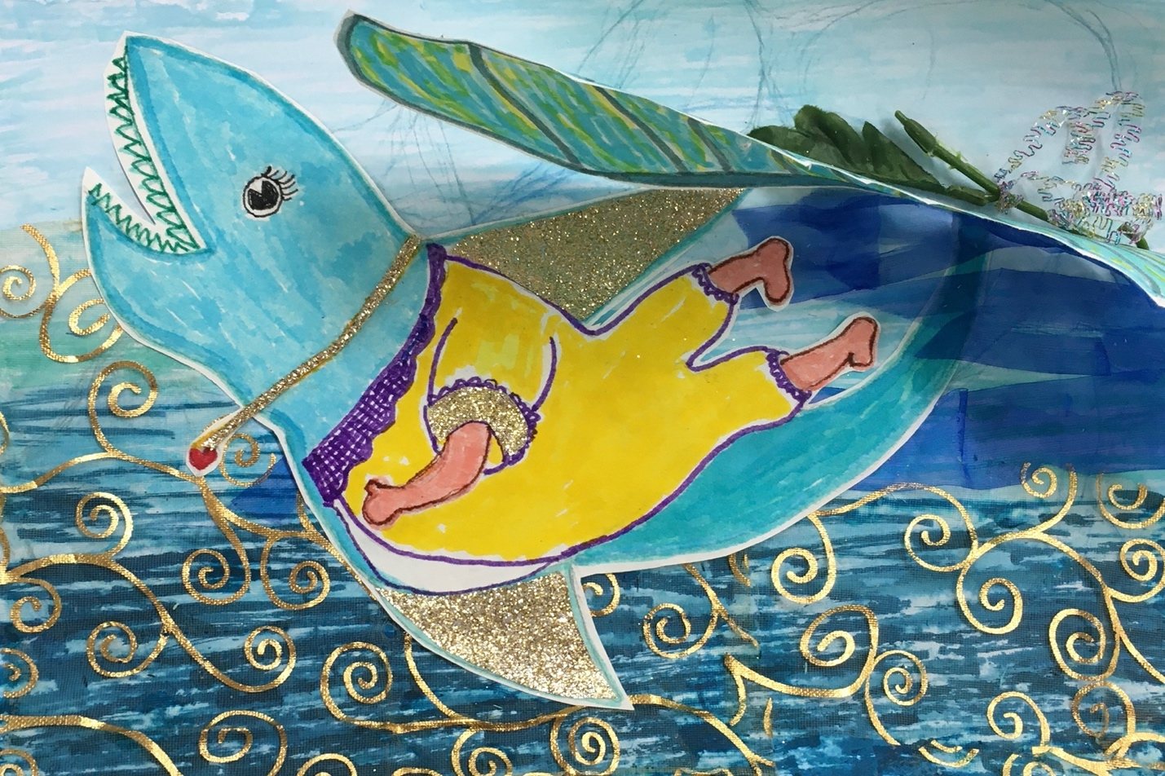

At this time, she also found she loved working part-time in retail at a toy store. Eventually, after working full-time for a group of high-tech companies, she returned to retail, working part-time at a luggage store, a bookstore, and then a Japanese gift shop. At the age of 60, she decided to study gerontology at SJSU, and earned her certificate to work with aging seniors.

An aging senior herself, Shirley learned to play both Taiko Drums and ukulele, and she loved singing to entertain seniors. Her most recent retirement from active employment was in 2015 at the age of 82, and continued to seeing opportunities to learn, to share what she was learning, and to entertain seniors. She encourages her friends to delve into their own cultural history, art, music, and dance and to cherish the embellishments that former generations have used to bring joy to their lives. She encourages her friends to preserve artifacts to be treasured by future generations.

Shirley began writing, producing, and directing plays for seniors at the Yu-Ai Kai Japanese Community Senior Center in San Jose’s Japantown. She wrote the scripts and each person in her group chose a character’s part to read. Although Shirley did not sew, she fashioned all the costumes from sheets of plastic, adding fittings and findings, as necessary to transform the most basic materials into recognizable outfits that helped convey the story she had written. She now works with a team of seniors who enjoy expanding their talents in writing and producing plays.

Her aim through her plays was to make people happy. Shirley said, “Once we counted 150 laughs and chuckles at one of my fractured fairy tales at the Senior Center.” Little did that elementary school teacher, from so long ago, know how much happiness Shirley would bring to people when she predicted that “Toshi will grow up to be a good clown!” Shirley’s motto is still “Be silly, laugh and be happy!”

Shirley began volunteering as a docent for the Japanese American Museum of San Jose. Having heard stories from other Japanese Americans, she was inspired to tell the story of her internment.

To tell her story, she decided to go on a pilgrimage back to the camp, Tule Lake. She turned to her friend Kelly Priest to help capture that experience and turn it into a short film. The film is called “Return to Tule Lake,” and became a winner for the “Most Inspiring Woman in a Film” at the Los Angeles Film Awards in April 2019.

At 93, her husband Sam needed a caregiver to provide Shirley with a few hours a week to work on her own. She found a caregiver who was interested in art, that inspired Shirley to order “paint-by-numbers” kits for them both. She watched with fascination as Sam added his own vibrant colors to those indicated on the canvas, until a more fiercely snarling tiger emerged. The caregiver continued to explore art with Sam as Shirley spent her two hours a week in her art class.

Shirley finds that the Tuesday morning Poetry in Art class has enriched her retirement and opened her to new ideas and new materials for art. She learns from all her classmates, and they learn from her. She continually researches facts and combines them with her imagination in developing ideas for her poems and makes sure she has accurate statements in her poetry about subjects such as lizards, waves, or dancing.

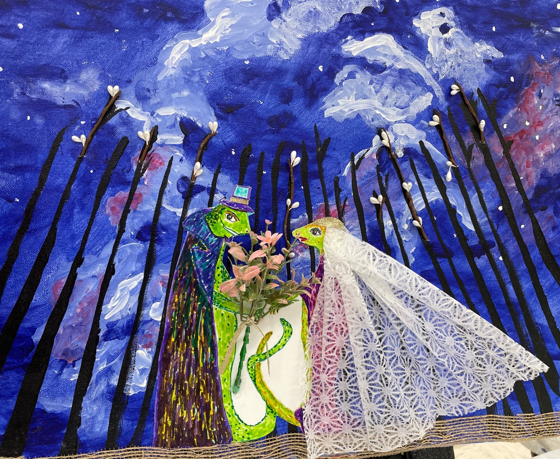

Always seeking new and interesting experiences, for her 89th birthday, Shirley decided to have a lesson in ballroom dancing. She expressed her joy after the lesson with the creation of an exuberant collage that captured her excitement. Shirley used photographs of herself and her dance instructor to create a celebratory collage. Working with a yellow background, she used portions of the photographs and duplicated herself dancing in different positions, and a splash of ink on rice paper formed a swirling skirt. She glued down everything except for the arms which she wanted to remain loose from the yellow background, to flutter forever in any breeze.

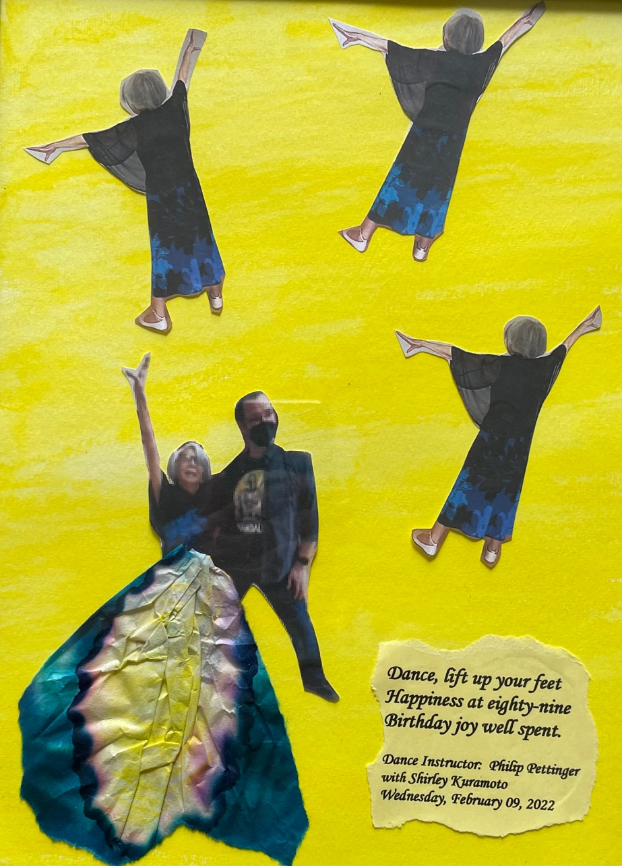

Shirley also wrote this poem to go with her art piece:

Dance, lift up your feet
Happiness at eighty-nine
Birthday joy well spent.

After all of her own adventures and experiences, Shirley encourages other retirees with these words: “Believe in yourself. Be like the bamboo plant. Live life in strength with humility and peace. Look for something that makes you happy every day. Make other people laugh.” As she prepares for sleep each night, Shirley thinks of poetry. She knows she needs a challenge in her life each day. She thinks of herself, climbing Half Dome at Yosemite, as a metaphor for life. She declares, “I did it for me; I climbed
Half Dome!”

