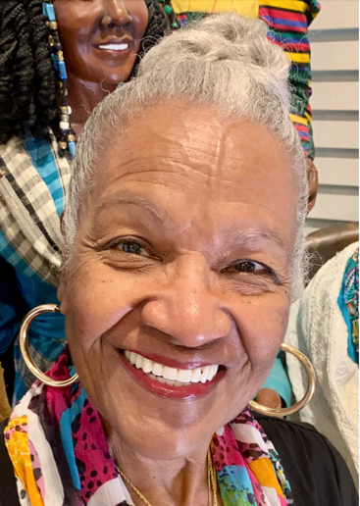

MIDGE ROBINSON

Midge Robinson has found joy and meaning in art, and fulfillment in retirement. One of her mottos is, “It takes a long time to grow young.” This becomes evident when considering the variety of her creative adventures in her retirement.
Family is important to Midge, and she enjoys visits with their four children, two grandchildren, three great grandchildren and a “grandson-dog.”

Midge’s art adventures began when her first-grade teacher in Columbus, Ohio praised the work on her mimeographed coloring assignment: “You stayed within the lines, and your colors are vibrant.” That praise made the young Midge glow with pride. If that teacher could see Midge’s art today, she would recognize the vibrant colors; but now Midge the artist is purposely coloring outside the lines.

As a young girl, Midge had a very creative and practical artistic interest: cutting and styling hair. One day when 12-year-old Midge was walking home from a friend’s house, an elderly neighborhood woman called out to her “Come here little girl, I want to give you something.” It was a pair of “curling irons.” Midge accepted them, even though she did not know how they worked she was curious enough to try them. She learned to use them by experimenting on her sisters’ hair. Soon Midge became known as the “kitchen beautician.” She earned spending money from hair styling, and years later became a licensed beautician and cosmetology instructor.

Midge the teenager was active in church, girls social club, civic fund drives, after school sports and summer fun activities. She enjoyed art and recalls how a high school field trip to Ohio State University stimulated an interest in ceramics. As a result of what she saw there, she made a small Venus de Milo replica in clay. The naked Venus shocked her 11th grade teacher, and this reaction deterred Midge at the time from further exploration in ceramics.

Midge met her future husband when she was in an 11th grade health class. She tripped over an easel and sprawled out the doorway into the hall, as the football captain baseball star, and honor student – Phil Robinson walked by. Though they didn’t connect at the time, as Cupid would have it, they met, fell in love, and married. Phil attended Ohio State University to earn a B.A. in business administration; and Midge became the traditional homemaker, caring for their two young children. Over the years, and the blessing of two more children, she still found time for family, church, community activism and eventually college, followed at last by — Art!

Midge’s family moved several times due to Phil’s career path. From Ohio to Kentucky, to California, to Illinois and back to California where Midge also worked. It was in Louisville, Kentucky, that Midge left her employment as Parent Liaison for Head Start program in 27 Louisville Public schools to enter a two-year Community College where she graduated cum laude. She earned her bachelor’s degree in Elementary Education from Spaulding College and was employed as Education Director for parents of infants from birth through 4 years.

In 1977 Midge’s family transferred to San Jose, California, and she worked as an elementary school substitute teacher. Midge then became a licensed cosmetologist and instructor who thoroughly enjoyed teaching high school vocational students and adults. The next move was Bolingbrook, Illinois. While Phil worked, Midge was active with church, community, yoga, swimming, sign language, jewelry making and metaphysics. Why all these activities and courses? They fulfilled Midge’s desire for creative expression, they were spiritual and therapeutic activities that enriched her, and provided for continued and education and growth.

Two years later they happily moved back to Milpitas, California, in closer proximity to their adult children, and the joy of interacting with their first grandchild. Midge, and her husband purchased and operated Hillview Printing in Milpitas and after it closed, Midge returned to graduate school, and Phil to industry.

At San Jose State University (SJSU), Midge planned to become a Marriage and Family Therapist, and shortly discovered her program had been dissolved. She left SJSU and turned to The Institute of Transpersonal Psychology where she enrolled in the Marriage and Family Therapist program, only to discover this school was several years from being accredited. So she returned to SJSU to finish her studies; and in 1992, earned her M. Ed. in Educational counseling with a minor in Psychodrama.

During her final semester at SJSU, Midge discovered doll making and in a psychodrama class project, she used one of her dolls as a “Fortuneteller.” It was so successful that Midge knew she wanted to incorporate dolls in psychodrama counseling sessions. The opportunity came a few years later after telling a friend about the doll interaction at SJSU. Midge’s friend told her a story that changed the trajectory of her art and life. It was of a male friend who said he had been pregnant with a doll for nine months, birthed it, (metaphorically) and was exhibiting it in Berkeley show entitled “The Way of the Doll: The Art and Craft of Personal Transformation.”

Midge attended the show and enrolled in “The Way of The Doll, School of Sacred Art.” Then for two years made life-size dolls from clay. Midge sculpted each doll from porcelain clay beginning first with the feet as the base, then moving up the body until the face revealed the doll’s identity.

The Doll Within

The Doll Within has a story to tell,
If we would but know how to listen.
The doll withing has a story to tell,
It sparkles and glows and glistens.
Come close…draw nigh
Let your imagination fly.
What will she tell you, what will she say
to ears that have learned not to hear?
How will she make your heart’s desire
so clear?
Myth? Magic?
It’s truth, veiled, hidden secreted away;
coming forth through story cloth, wood,
wire, fire and clay!
The dolls say what wasn’t said…
The Doll speaks and we listen:
Words women weren’t allowed to say
The doll speaks words men weren’t allowed to say
Words children weren’t allowed to say,
Words Races weren’t allowed to say.
The Doll speaks and her words are Power.

Midge Robinson
Copyright January 2001

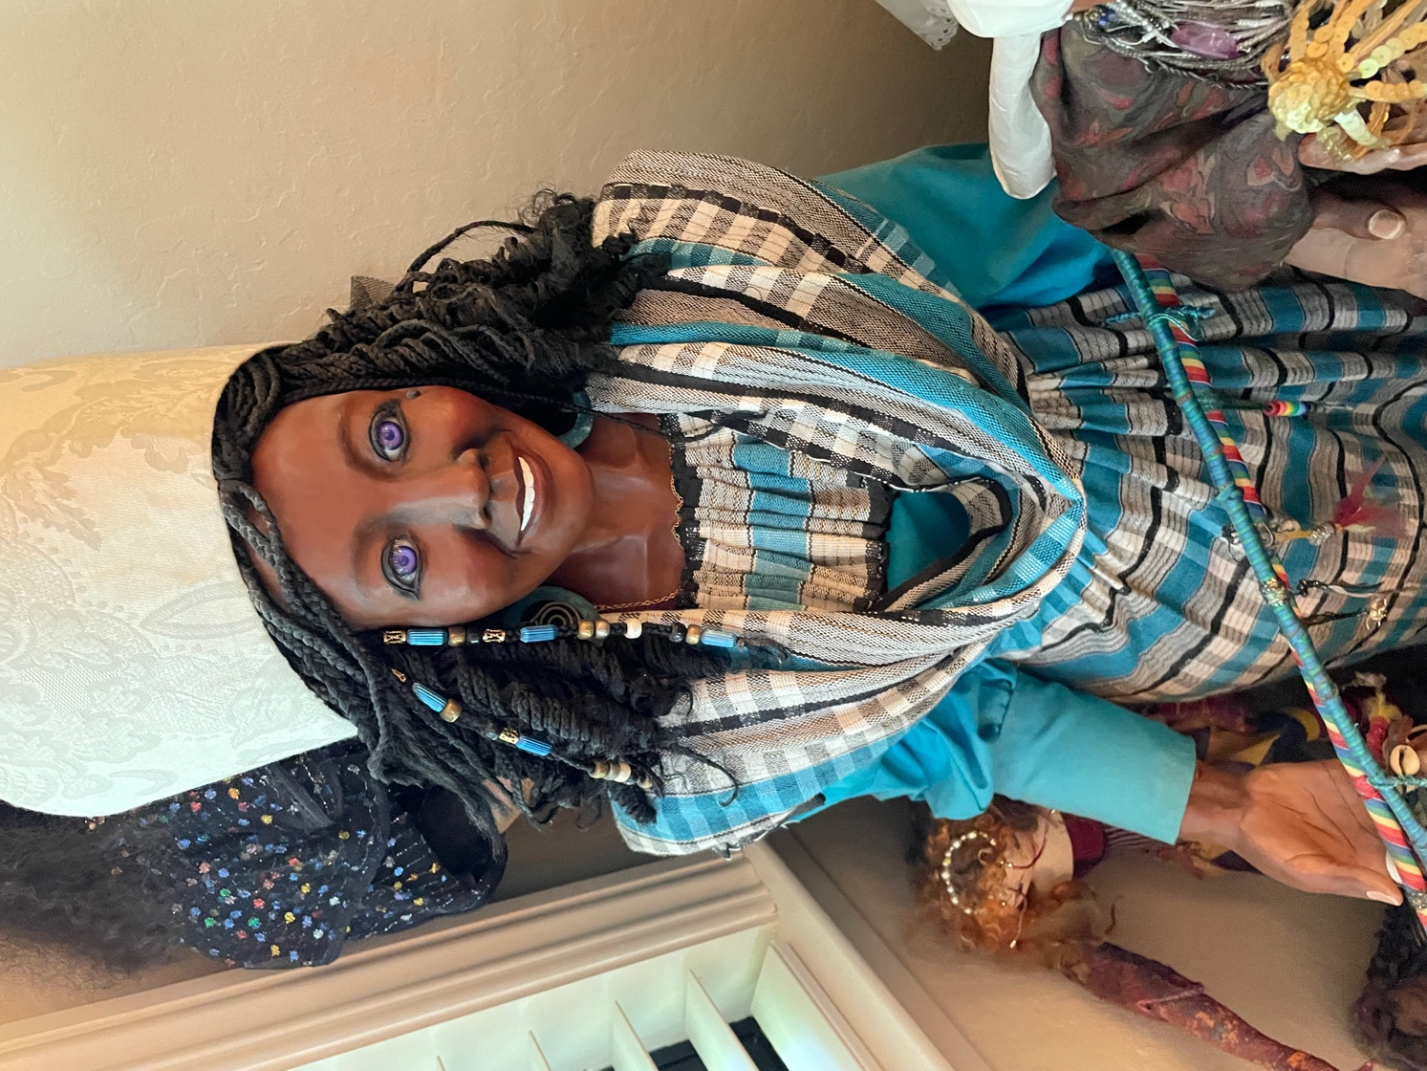

Each of her dolls represent a character from her personal story, her family history, myth, or from Midge’s vivid imagination. The process also included writing Haiku, Sestina poetry, and stories to bring her characters to life. Psychodrama was used to make the character dolls interactive with her mythic stories and vignettes. Exhibiting the dolls in the Bay Area was gratifying, but of greater interest was helping other people create their own dolls as she taught workshops at her church and from her home studio.

In 1997, Midge began making quilts and joined several local quilting guilds. Continuing an African American tradition, she used fabric and cuttings from the discarded clothing of loved ones to personalize the quilts. Her first quilt was piecing together tiny scraps of fabric that symbolized putting together memories of her mother’s long descent into Alzheimer’s disease and death. Ten years later, Midge made large block quilts from her mother’s clothing for her three siblings and herself. Today as Midge hugs the quilt of vibrant colors to her body, she says “It is like having my mother’s arms around me.”

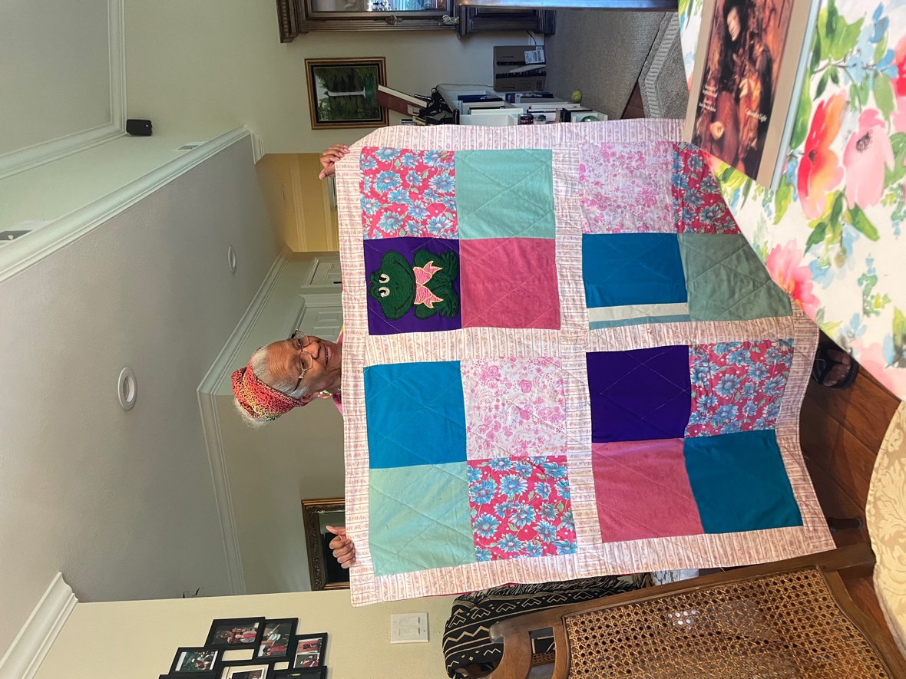

Following that grief experience and her counseling work, Midge became a peer grief counselor at the Center for Living with Dying, then worked as Assistant Volunteer Coordinator/Trainer. She was invited to exhibit and tell her doll and quilt stories at a special full-evening program for the Center and its clients.

While recuperating from double knee replacements in 2004, Midge was inspired by the famous television artist Bob Ross. She enrolled in an oil painting class in Milpitas. With humor, she says, “Learning from my new teacher was easy because we quickly established a rapport since we both were struggling with double knee replacements. We were ‘sisters of the knees!’”

In 2009, Midge trained with Seena Frost, founder of SoulCollage® and became certified as Soul Collage® facilitator. Collage allowed her to express her imaginative skills in a new and different medium. She expanded this in a three-year art VisionQuest which combined myth, personal story, poetry, and creative writing, with Soul Collage card making. In 2010 Midge planned and helped facilitate a SoulCollage® weekend retreat workshop and also conducted a workshop in her home.

A few years after moving to The Villages, Midge signed up for acrylic painting classes sponsored by The Villages Arts & Crafts Association. Covid caused classes to be moved to Zoom. Midge says, “I now prefer on-line classes because I can see the unobstructed demonstration and can benefit from class questions and feel a personal connection. She enjoyed the all-media classes because of the variety of artistic media offered.

Colored Pencil painting in Jeff Bramschrieber’s classes, inspired Midge to enroll in Bonny Snowdon’s year-long Art Academy on Zoom from London. Her cat is an example of her colored pencil artwork.

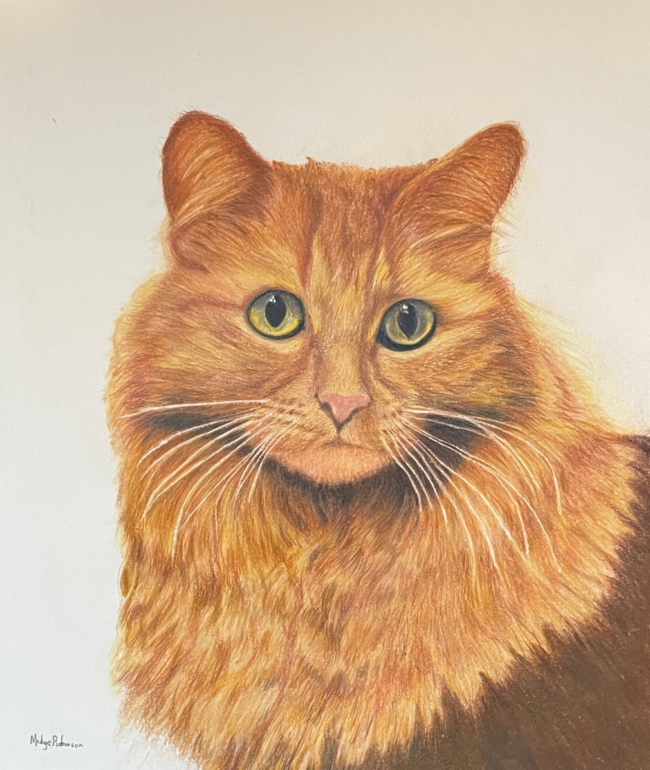

As she embarks on her new study of art with colored pencils, Midge offers this encouragement others in retirement: “Try anything – writing, drawing, quilting - and believe in yourself. I said I would never be able to do that.” However, she reasoned that classes are taken to learn from an instructor. She adds, “Stand behind everything you do and never stop believing in yourself because your art is an expression of you, regardless of genre or age.”

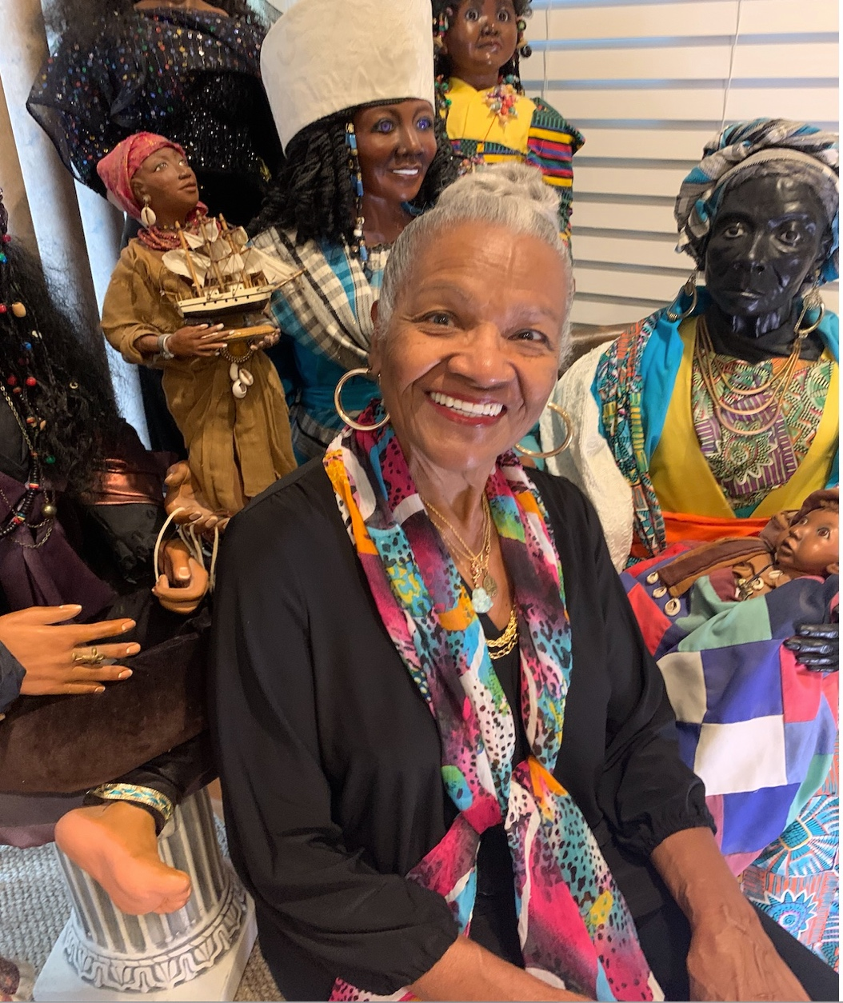

Midge believes that everything does not need to be done perfectly: “Just enjoy each new adventure, and know that is life imitating art.”

